

**NAME** :  *KASHIF MAJID DAR*

**BRANCH**:  *CS B-1*

**BATCH**: *2019-23*

**PRN:**  *19070122084*

**Programming and Problem Solving Lab**

**ASSIGNMENT 7**

1. Python Program to Remove Punctuations from a String.

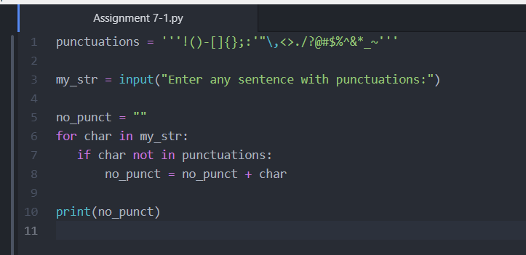

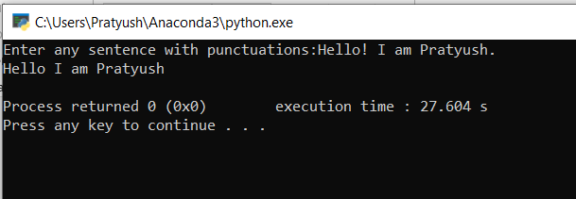

2.Write a python program to reverse a string (put your own logic).

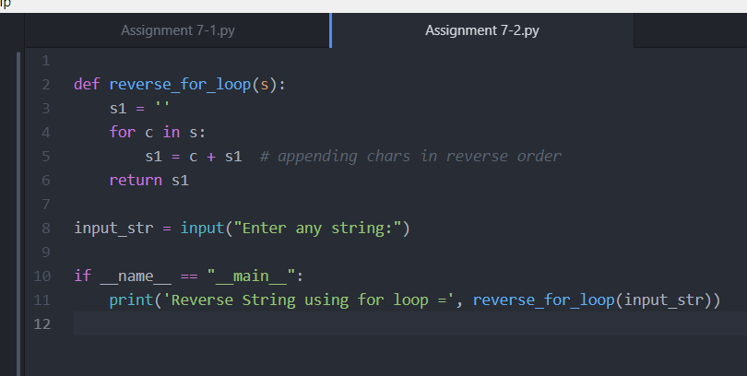

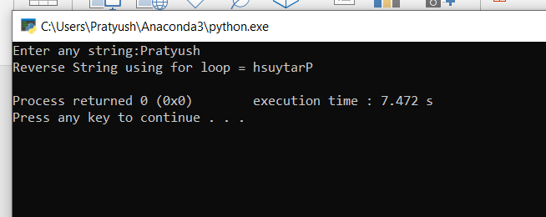

3.Program to count the number of each vowel in a string

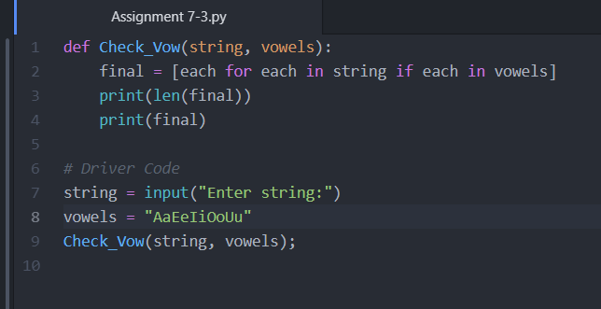

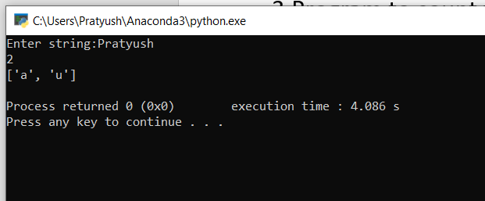

4.Program to check if a string is a palindrome.

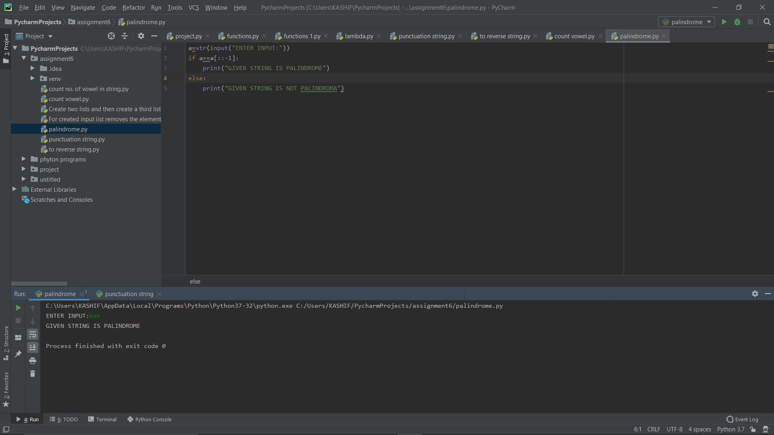

5.Program to multiply two matrices using nested in loop

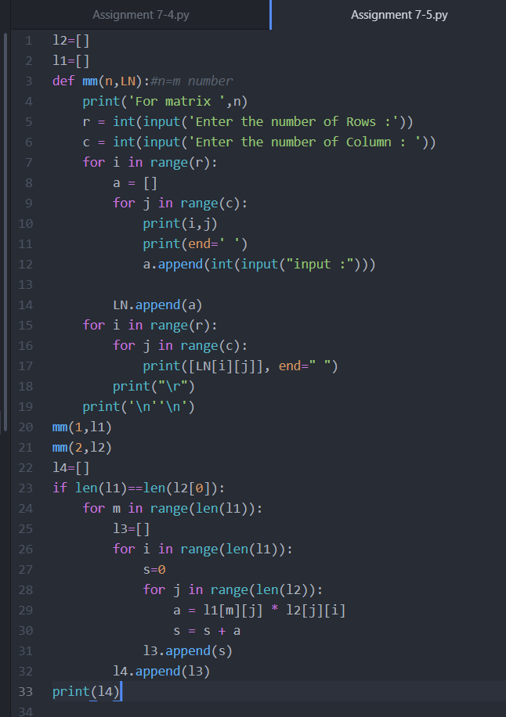

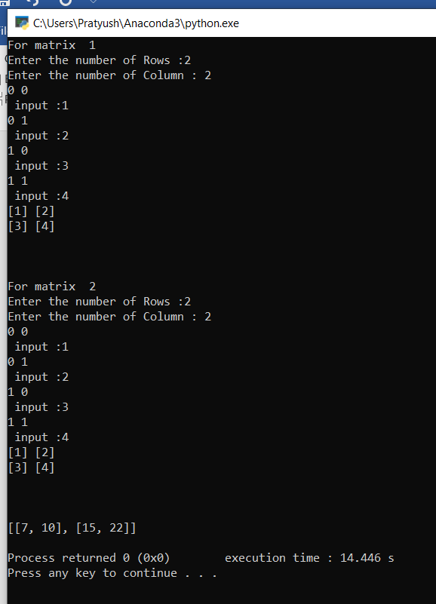

6. Write a program to count the number of times an element is present inside a tuple.

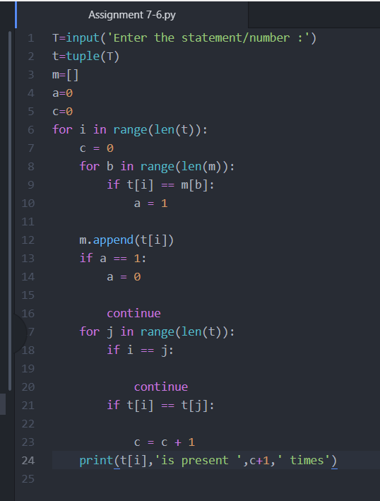

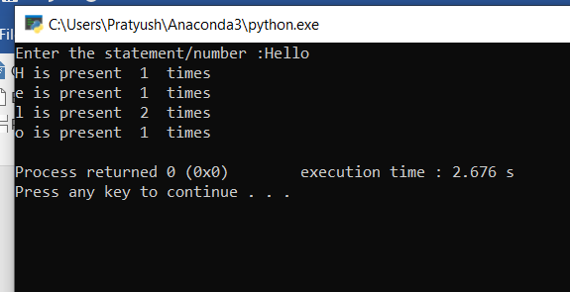

7. Write a program for the following operations on Tuple.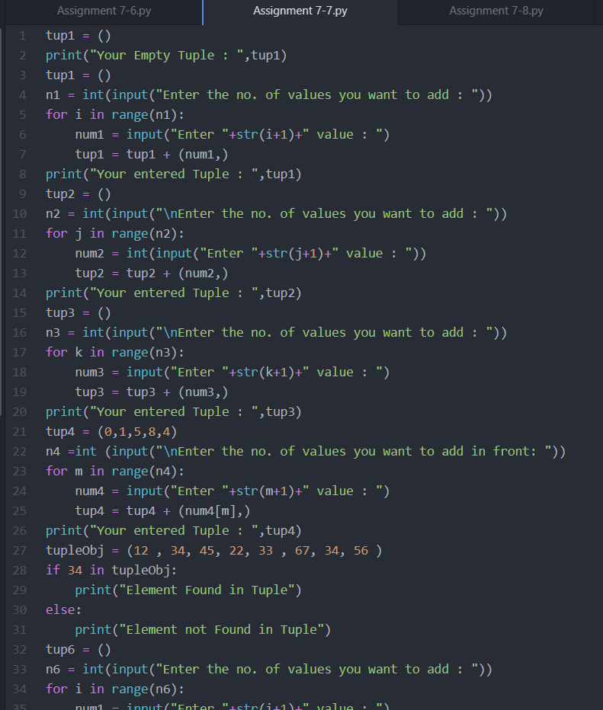

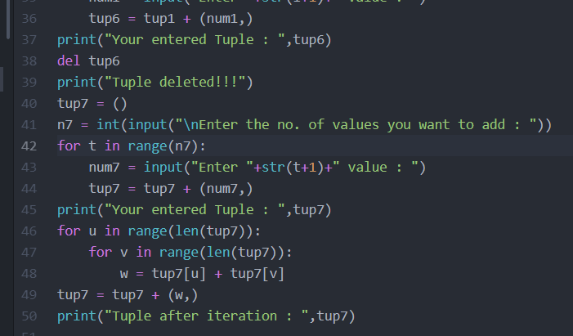

8. WAP that input a number n and creates a tuple containing: n, 2n, 3n and 4n.

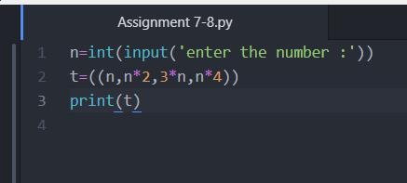

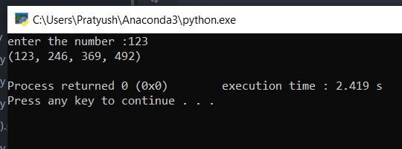

9. WAP to print every 2nd element of a tuple T, raised to power 2.

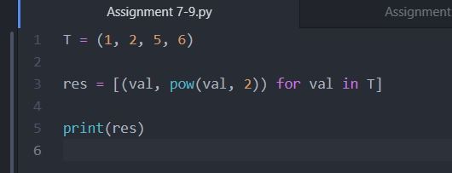

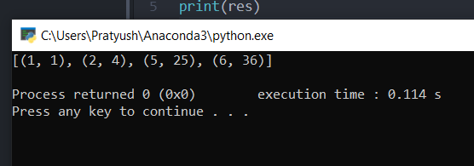

10. Write a python program that inputs two tuples and creates a third that contains all elements of the first followed by all elements of the second.

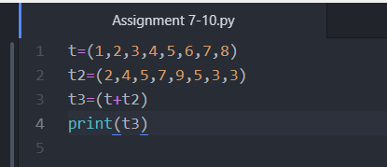

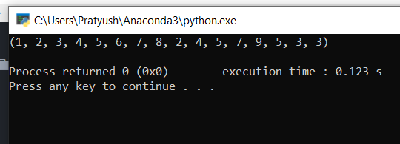

11. WAP that takes a tuple with words in “Pig Latin" and translates it back to original test.

